**COMPSYS 301 Project Info and Notes**

* SensorPos.txt file is written as

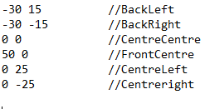

Order of the sensors is important when using virtualCarSensorStates[i] function, the order corresponds to the value of i to be used.

* If virtualCarSensorStates[i] is equal to zero, that sensor detects the line.
* Angular rotation is degrees per second, I.e. virtualCarAngularSpeed_seed = 60 means the robot rotates 60 degrees per second.